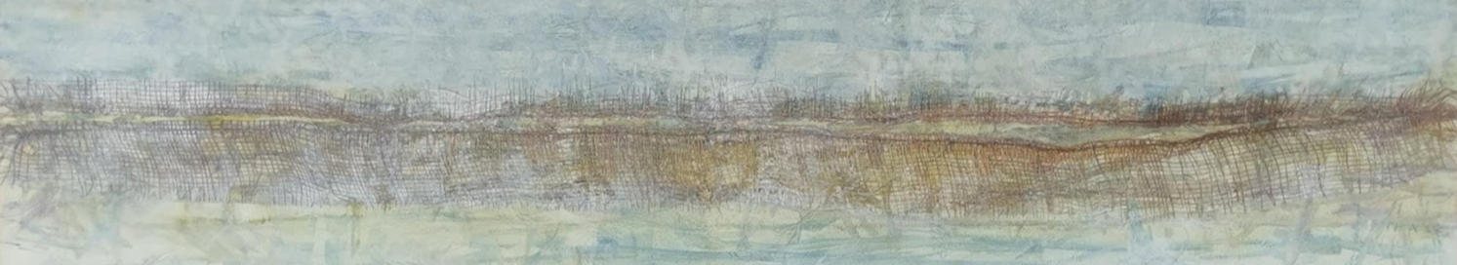
Big Lagoon Bruny Island
Where: in my studio @ 66 Websters Rd, Gordon, Tasmania

When: March 19/20, 2022
2-day workshop
10am – 4pm each day

Explore mixed media techniques including mark making, drip, dip, dye, print and resist with natural pigments, rust, indigo and more. Use a range of drawing materials, paint and other mediums on a variety of surfaces to create a series of mixed media 2D works on canvas, paper and cloth. This surface could become the background for experimental and intuitive hand stitch. Learn simple book making techniques to construct a personal record of the workshop.
Suitable for all levels of experience
I’ll provide tea, coffee, and morning tea
Bring something to share for lunch
Cost $200.00 + $40.00 dye, auxiliaries, and some materials
Contact mahdi to book or for further information
Phone 0419 234 167 or 6292 1043 or email mahdi.chandler@gmail.com

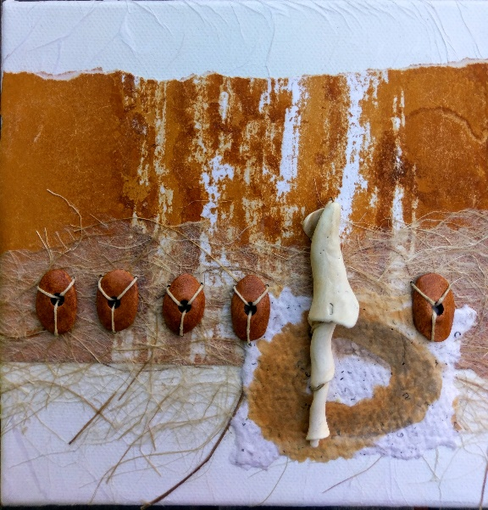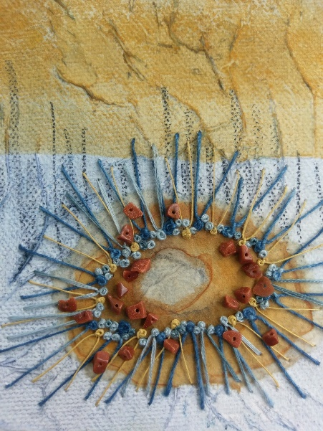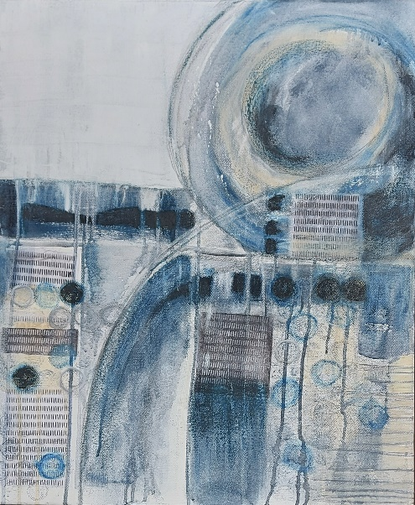
Print, stamp, stencil, dye, paint and collage techniques, on paper and canvas works in progress and details of larger works.

