Stitching & Beyond Creative Day

Saturday 31st October 2020
10am – 4pm
Tutor: Gemma Black

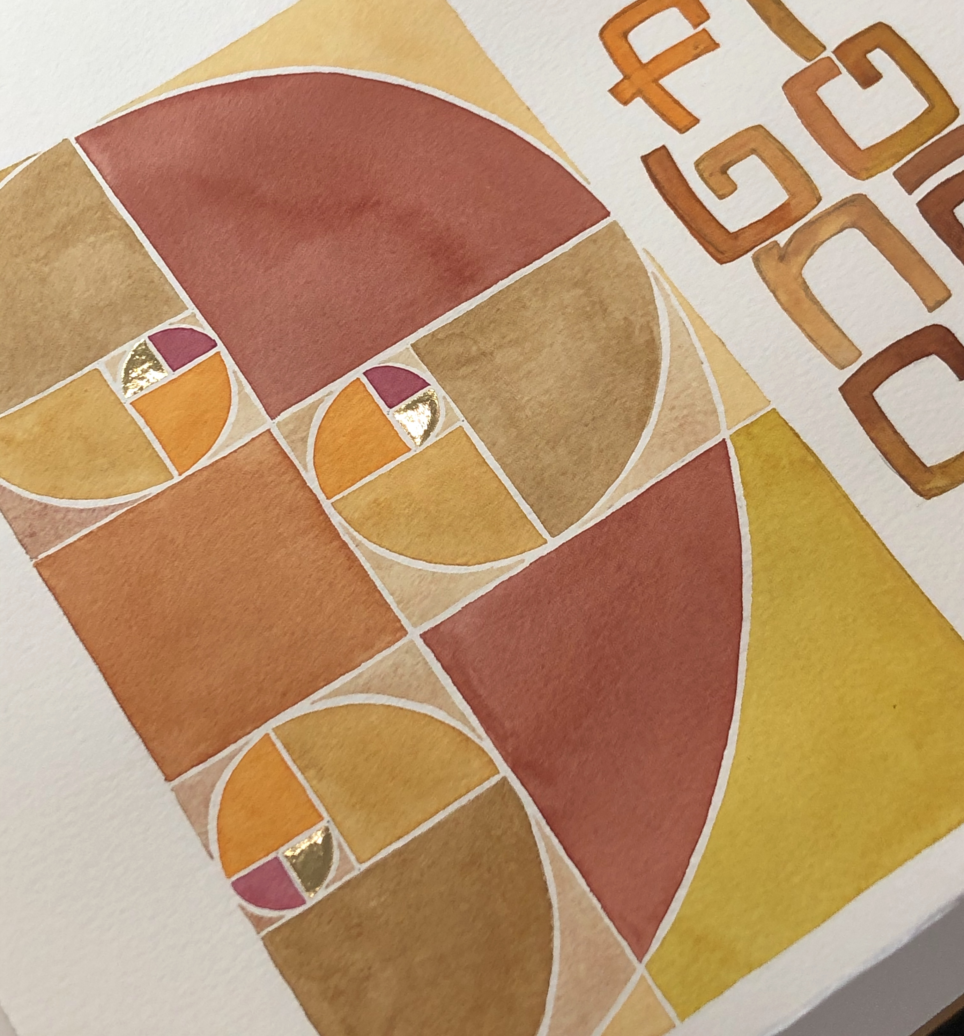

Title: Fibonacci, gold leaf & watercolour

Description: As the basis of all living things we will follow the Fibonacci sequence using it to design a little work in watercolour and gold leaf on paper.

Materials:
- Any watercolour you already have and mixing supplies. There will be enough to share.
- One or more small short-haired brushes 000 size
- A couple of sharp lead pencils of mechanical pencils
- Two jars for water
- A pair of compasses (a circle drawing tool) in working order
- A clear ruler
- An eraser
- A note book
- A rag or tissues or absorbent paper roll

Gold leaf, gilding size and fine art paper
will be supplied by Gemma for a small fee of $5.

